Alex Jehle

August 11th, 2020

IT FDN 110 A

Assignment 06

GitHub: <https://github.com/anjehle/IntroToProg-Python-Mod06>

To Do List Script with Classes and Functions

# Introduction

The purpose of this program is to prioritize and update a to do list tasks based off of a menu selection and input from the user.

# Program

The program Assigment06_starter.py (Figure 1) consists of two classes with various functions, as well as a main script body. It begins by opening and reading or creating the to do text file, ‘ToDoList.txt’. The program then enters into a while loop for the menu, prompting the user for one of five choices: adding a new item, removing an existing item, saving data to the file, reloading, or exiting. Each time data is processed, the program returns to the main menu, printing all the current tasks in the list and the menu of options. The user then inputs their choice and the program enters into the relevant processing or IO functions based on if statements.

# ---------------------------------------------------------------------------- #  
# Title: Assignment 06  
# Description: Working with functions in a class,  
# When the program starts, load each "row" of data  
# in "ToDoToDoList.txt" into a python Dictionary.  
# Add the each dictionary "row" to a python list "table"  
# ChangeLog (Who,When,What):  
# RRoot,1.1.2030,Created started script  
# RRoot,1.1.2030,Added code to complete assignment 5  
# AJehle,8.11.2020,Modified code to complete assignment 6  
# ---------------------------------------------------------------------------- #  
  
# Data ---------------------------------------------------------------------- #  
# Declare variables and constants  
strFileName = "ToDoFile.txt" # The name of the data file  
objFile = None # An object that represents a file  
dicRow = {} # A row of data separated into elements of a dictionary {Task,Priority}  
lstTable = [] # A list that acts as a 'table' of rows  
strChoice = "" # Captures the user option selection  
strTask = "" # Captures the user task data  
strPriority = "" # Captures the user priority data  
strStatus = "" # Captures the status of an processing functions  
  
  
# Processing --------------------------------------------------------------- #  
class Processor:  
 *""" Performs Processing tasks """* @staticmethod  
 def read_data_from_file(file_name, list_of_rows):  
 *""" Reads data from a file into a list of dictionary rows* ***:param*** *file_name: (string) with name of file:* ***:param*** *list_of_rows: (list) you want filled with file data:* ***:return****: (list) of dictionary rows  
 """* list_of_rows.clear() #clear current data  
 from os import path  
 if path.exists(file_name):  
 file = open(file_name, 'r')  
 for line in file:  
 task, priority = line.split(",")  
 row = {"Task": task.strip(), "Priority": priority.strip()}  
 list_of_rows.append(row)  
 else:  
 file = open(file_name, 'w')  
 print('doesnt exist')  
 file.close()  
 return list_of_rows, 'Success'  
  
 @staticmethod  
 def add_data_to_list(task, priority, list_of_rows):  
 *""" Adds task from input to the list of dictionary rows* ***:param*** *task: (string) with name of task:* ***:param*** *priority: (string) with priority of task:* ***:param*** *list_of_rows: (list) you want filled with additional task:* ***:return****: (list) of dictionary rows  
 """* dicRow = {"Task": task.strip(), "Priority": priority.strip()}  
 list_of_rows.append(dicRow)  
 return list_of_rows, 'Success'  
  
 @staticmethod  
 def remove_data_from_list(task, list_of_rows):  
 *""" Removes task from input from the list of dictionary rows* ***:param*** *task: (string) with name of task:* ***:param*** *list_of_rows: (list) you want task removed from:* ***:return****: (list) of dictionary rows  
 """* boolfound = False  
 for dicRow in list_of_rows:  
 if dicRow["Task"] == task:  
 list_of_rows.remove(dicRow)  
 boolfound = True  
 if boolfound == False:  
 print('Task not found')  
 return list_of_rows, 'Success'  
  
 @staticmethod  
 def write_data_to_file(file_name, list_of_rows):  
 *""" Writes data from list of dictionary rows to file* ***:param*** *file_name: (string) with name of file:* ***:param*** *list_of_rows: (list) you want added to text file:* ***:return****: (list) of dictionary rows  
 """* objFile = open(file_name, 'w')  
 for row in list_of_rows:  
 objFile.write(row["Task"] + ',' + row["Priority"] + '\n')  
 objFile.close()  
 return list_of_rows, 'Success'  
  
  
# Presentation (Input/Output) -------------------------------------------- #  
class IO:  
 *""" Performs Input and Output tasks """* @staticmethod  
 def print_menu_Tasks():  
 *""" Display a menu of choices to the user* ***:return****: nothing  
 """* print('''  
 Menu of Options  
 1) Add a new Task  
 2) Remove an existing Task  
 3) Save Data to File   
 4) Reload Data from File  
 5) Exit Program  
 ''')  
 print() # Add an extra line for looks  
  
 @staticmethod  
 def input_menu_choice():  
 *""" Gets the menu choice from a user* ***:return****: string  
 """* choice = str(input("Which option would you like to perform? [1 to 5] - ")).strip()  
 print() # Add an extra line for looks  
 return choice  
  
 @staticmethod  
 def print_current_Tasks_in_list(list_of_rows):  
 *""" Shows the current Tasks in the list of dictionaries rows* ***:param*** *list_of_rows: (list) of rows you want to display* ***:return****: nothing  
 """* print("******* The current Tasks ToDo are: *******")  
 for dicRow in list_of_rows:  
 print(dicRow["Task"] + " (" + dicRow["Priority"] + ")")  
 print("*******************************************")  
 print() # Add an extra line for looks  
  
 @staticmethod  
 def input_yes_no_choice(message):  
 *""" Gets a yes or no choice from the user* ***:return****: string  
 """* return str(input(message)).strip().lower()  
  
 @staticmethod  
 def input_press_to_continue(optional_message=''):  
 *""" Pause program and show a message before continuing* ***:param*** *optional_message: An optional message you want to display* ***:return****: nothing  
 """* print(optional_message)  
 input('Press the [Enter] key to continue.')  
  
 @staticmethod  
 def input_new_task_and_priority():  
 pass # *TODO: Add Code Here!* task = str(input("Which task would you like to add? ")).strip()  
 priority = str(input('What priority should ' + task + ' have?: ')).strip()  
 return task, priority  
  
 @staticmethod  
 def input_task_to_remove():  
 pass # *TODO: Add Code Here!* task = str(input("Which task would you like to remove? ")).strip()  
 return task  
  
  
# Main Body of Script ------------------------------------------------------ #  
  
# Step 1 - When the program starts, Load data from ToDoFile.txt.  
Processor.read_data_from_file(strFileName, lstTable) # read file data  
  
# Step 2 - Display a menu of choices to the user  
while (True):  
 # Step 3 Show current data  
 IO.print_current_Tasks_in_list(lstTable) # Show current data in the list/table  
 IO.print_menu_Tasks() # Shows menu  
 strChoice = IO.input_menu_choice() # Get menu option  
  
 # Step 4 - Process user's menu choice  
 if strChoice.strip() == '1': # Add a new Task  
 task, priority = IO.input_new_task_and_priority()  
 lstTable, strStatus = Processor.add_data_to_list(task, priority, lstTable)  
 IO.input_press_to_continue(strStatus)  
 continue # to show the menu  
  
 elif strChoice == '2': # Remove an existing Task  
 task = IO.input_task_to_remove()  
 lstTable, strStatus = Processor.remove_data_from_list(task, lstTable)  
 IO.input_press_to_continue(strStatus)  
 continue # to show the menu  
  
 elif strChoice == '3': # Save Data to File  
 strChoice = IO.input_yes_no_choice("Save this data to file? (y/n) - ")  
 if strChoice.lower() == "y":  
 lstTable, strStatus = Processor.write_data_to_file(strFileName, lstTable)  
 IO.input_press_to_continue(strStatus)  
 else:  
 IO.input_press_to_continue("Save Cancelled!")  
 continue # to show the menu  
  
 elif strChoice == '4': # Reload Data from File  
 print("Warning: Unsaved Data Will Be Lost!")  
 strChoice = IO.input_yes_no_choice("Are you sure you want to reload data from file? (y/n) - ")  
 if strChoice.lower() == 'y':  
 lstTable, strStatus = Processor.read_data_from_file(strFileName, lstTable)  
 IO.input_press_to_continue(strStatus)  
 else:  
 IO.input_press_to_continue("File Reload Cancelled!")  
 continue # to show the menu  
  
 elif strChoice == '5': # Exit Program  
 print("Goodbye!")  
 break # and Exit

***Figure 1: ‘Assigment06_starter.py’ Script***

## Adding Data

If the user selects the option to add a new item, the program prompts the user to enter the task they wish to add, and then prompts for the priority. The program appends these items to the to-do list. The program then returns to the initial menu option. This is shown in Figure 2.

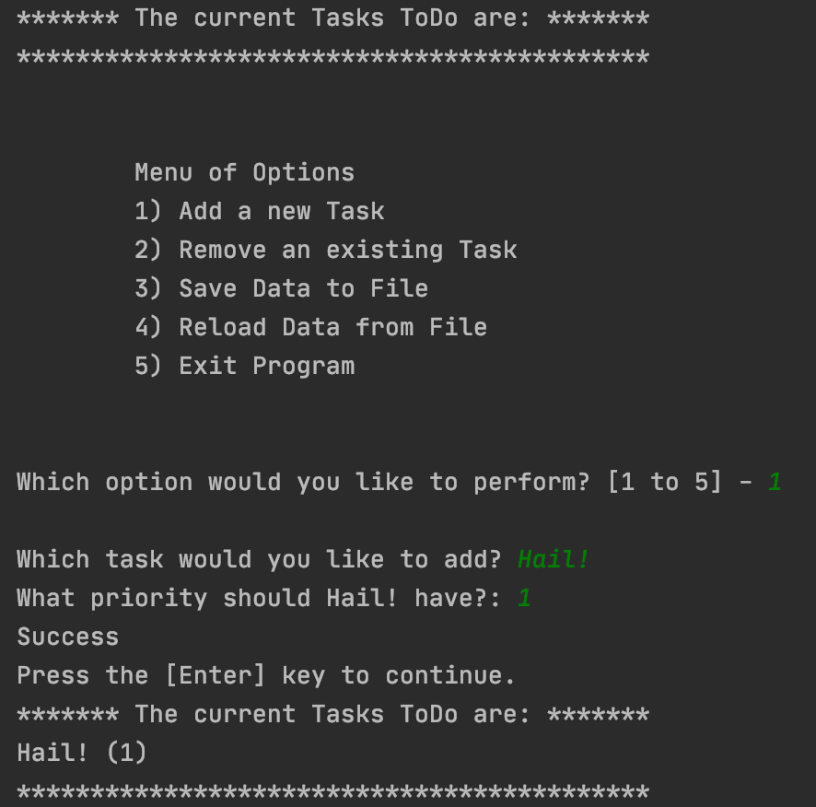 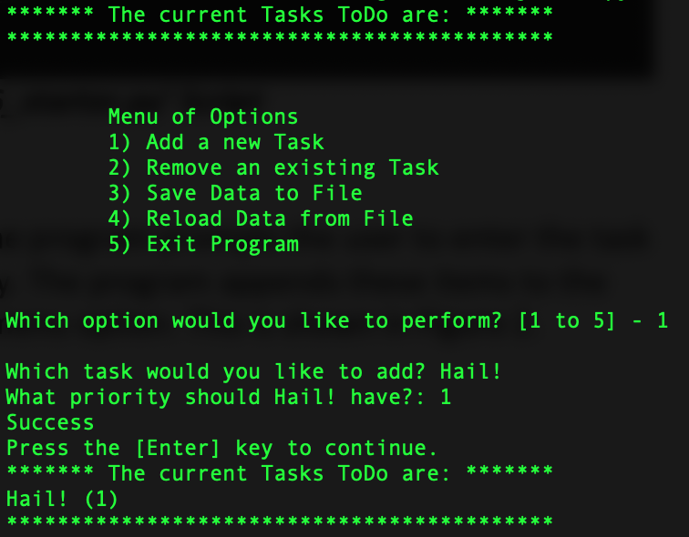

***Figure 2: Output of added data in PyCharm and the terminal***

## Removing Data

If the user selects the option to remove an item, the program prompts the user to enter the task they wish to delete. The program iterates through the program, removes that task from the to-do list, and displays a confirmation, as seen in Figure 3. The program then returns to the initial menu option.

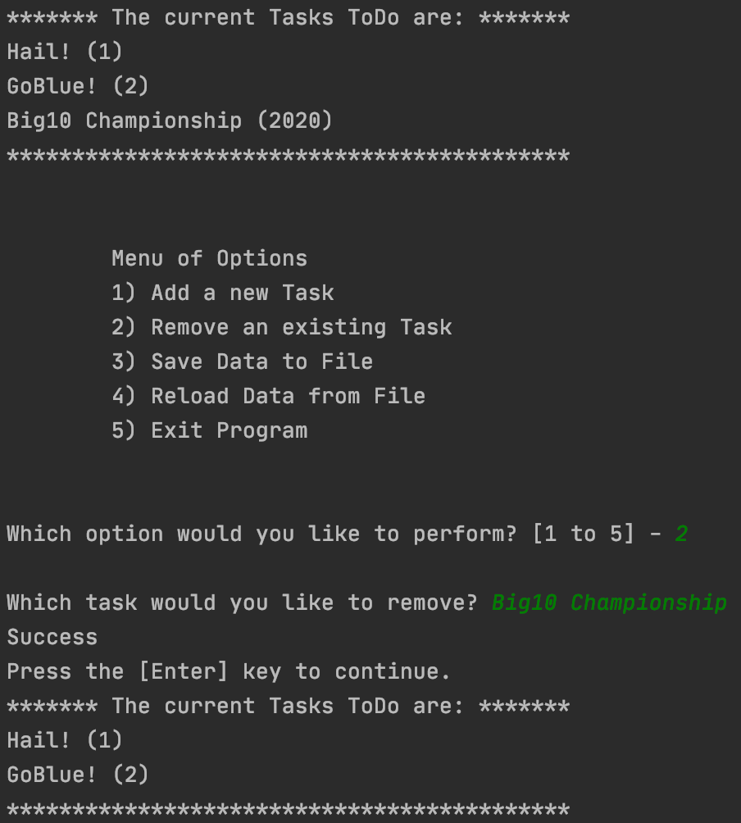 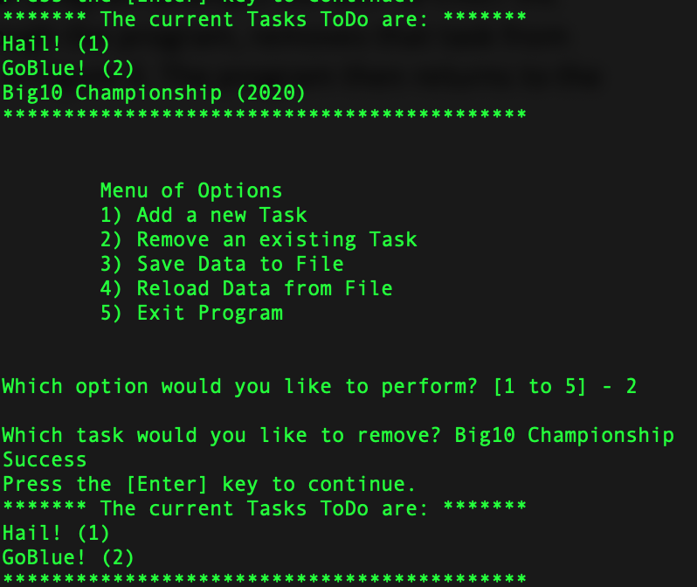

***Figure 3: Output of removing data in PyCharm and the terminal***

## Saving to the File

If the user selects the option to save then the program overwrites the current ‘ToDoList.txt’ with a copy of the data list read in at the beginning of the program and any changes applied. The program displays a confirmation message and after saves and returns to the main menu. This process is shown in Figure 4.

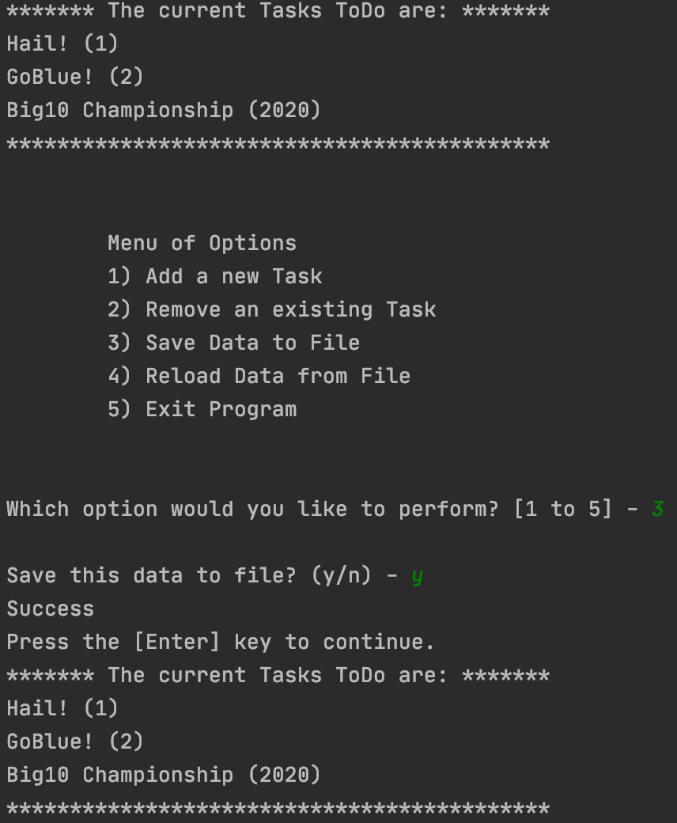 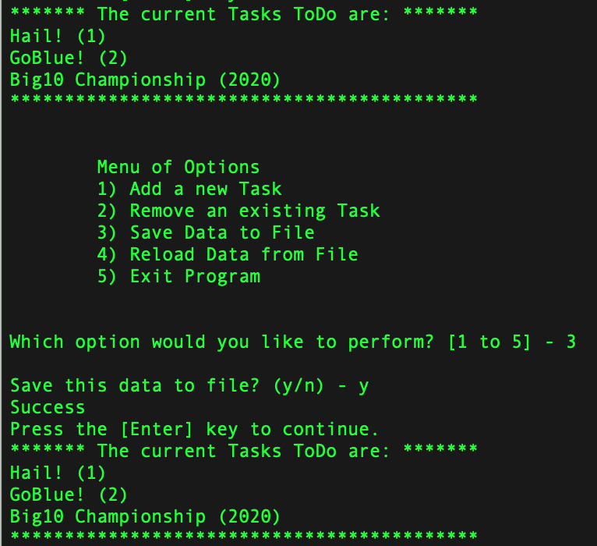

***Figure 4: Output after the data is saved in PyCharm and the terminal***

## Reloading Data from the File

If the user selects the option to reload then the program overwrites any changes with a copy of the most recently saved file. The program displays a message that unsaved changes won’t be saved, and after confirmation updates and returns to the main menu. This process is shown in Figure 5.

 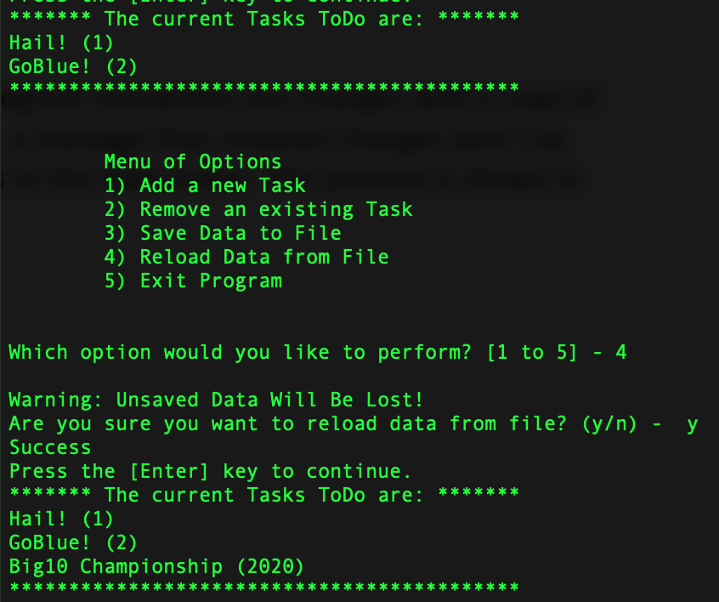

***Figure 5: Output after the data is reloaded in PyCharm and the terminal***

## Exiting the Program

If the user selects the option to exit then the program ends and says ‘Goodbye!’, as seen in Figure 6.

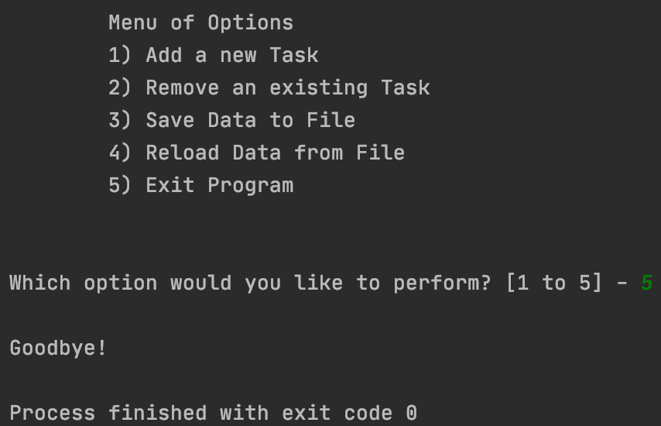 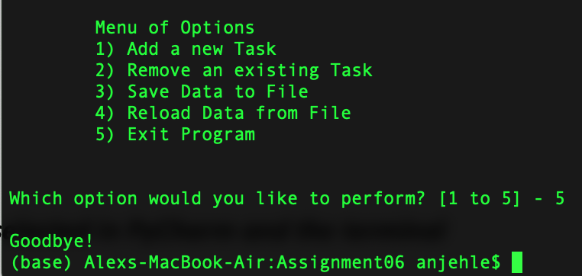

***Figure 6: Output after the exit option is selected in PyCharm and the terminal***

# Results

## Execution from PyCharm

The program Assigment06_Starter.py executed successfully from PyCharm. Two items were added and in both cases, both inputs were taken in as strings and the proper processing and output was observed (Figure 7). This program did not take a measurable amount of time to execute.

 

***Figure 7: Execution of ‘Assigment05_Starter.py’ in PyCharm***

## Execution from the terminal

The program Assigment06_Starter.py executed successfully from the terminal. One item was added and each task was taken in as a string and the proper processing and output was observed (Figure 8). This program did not take a measurable amount of time to execute.

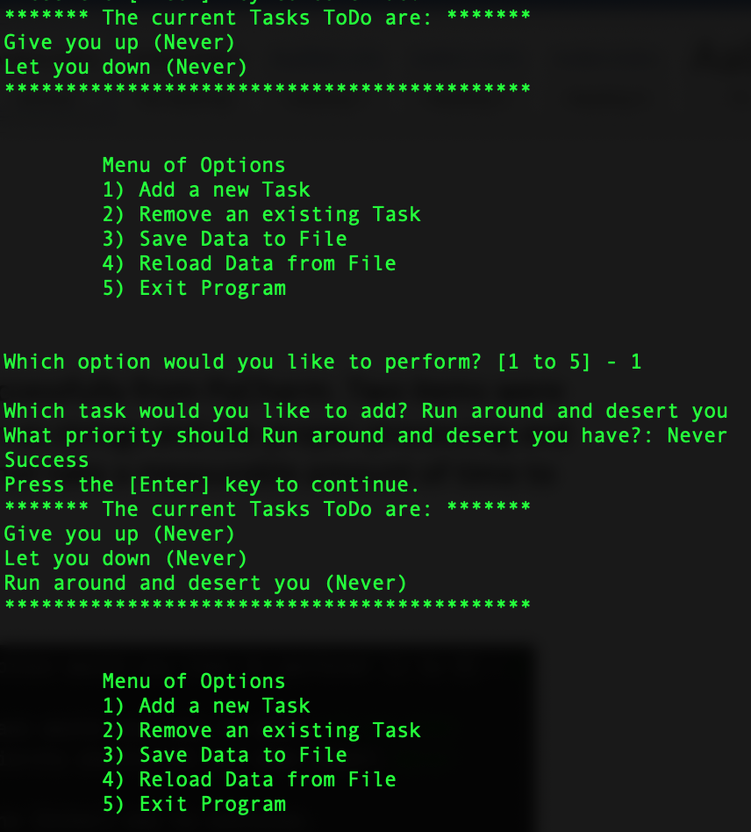 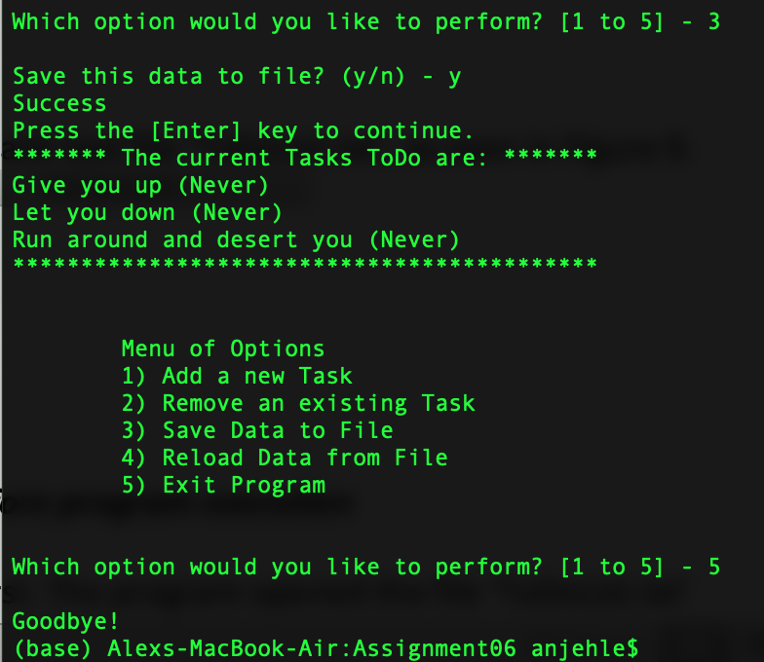

***Figure 8: Execution of ‘Assigment05_Starter.py’ in the terminal***

## Results

The program was launched in both cases with a blank text file ‘ToDoList.txt’, as seen in Figure 9.

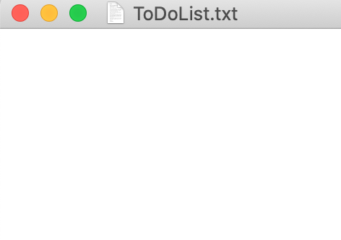

***Figure 9: ’ToDoList.txt’ before program execution***

The program ran successfully through PyCharm first. The program opened the file ‘ToDoList.txt’ and added two tasks and their priorities, as seen in Figure 10.

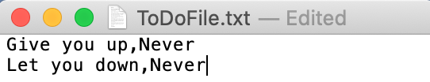

***Figure 10: Results stored in ‘ToDoList.txt’ after PyCharm execution***

The program ran successfully through the terminal second. The program opened the file ‘ToDoList.txt’ and appended one more item and its priority to the end, as seen in Figure 11.

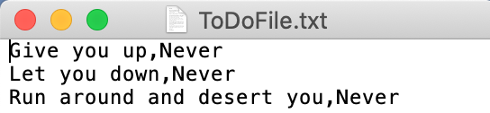

***Figure 11: Results stored in ‘ToDoList.txt’ after terminal execution***

# Summary

The program consists of 209 lines including comments and headers. The intended result to update the to-do list in one living file was achieved with no unintended consequences.